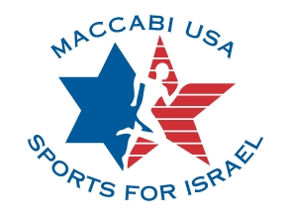

Maccabi USA Fast Pitch Softball tryout in New York City

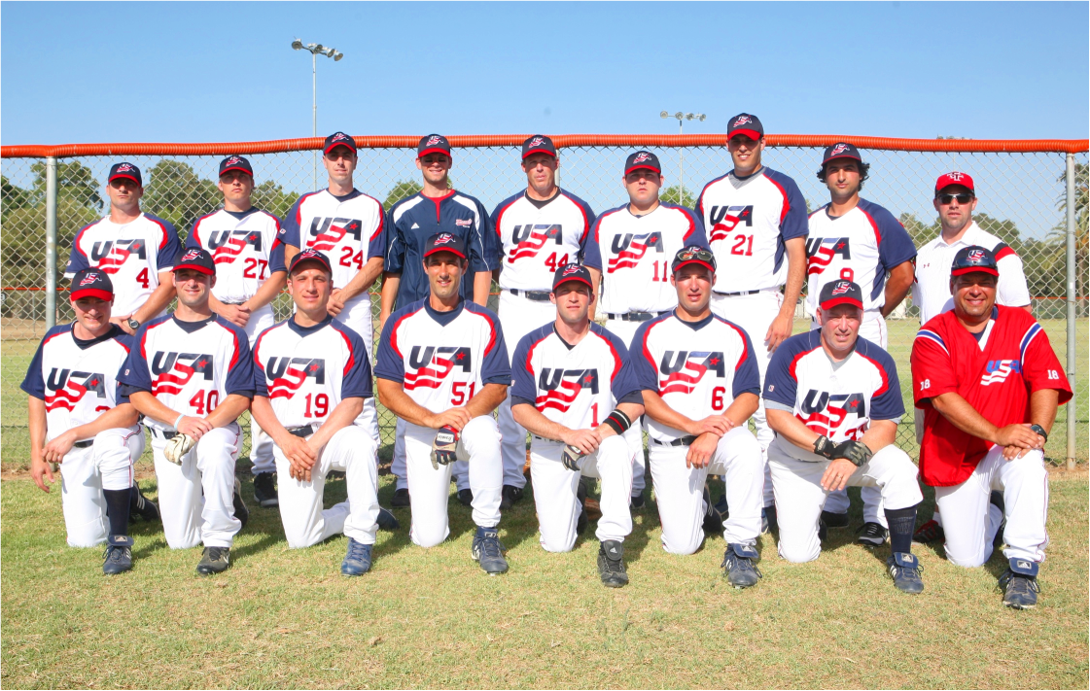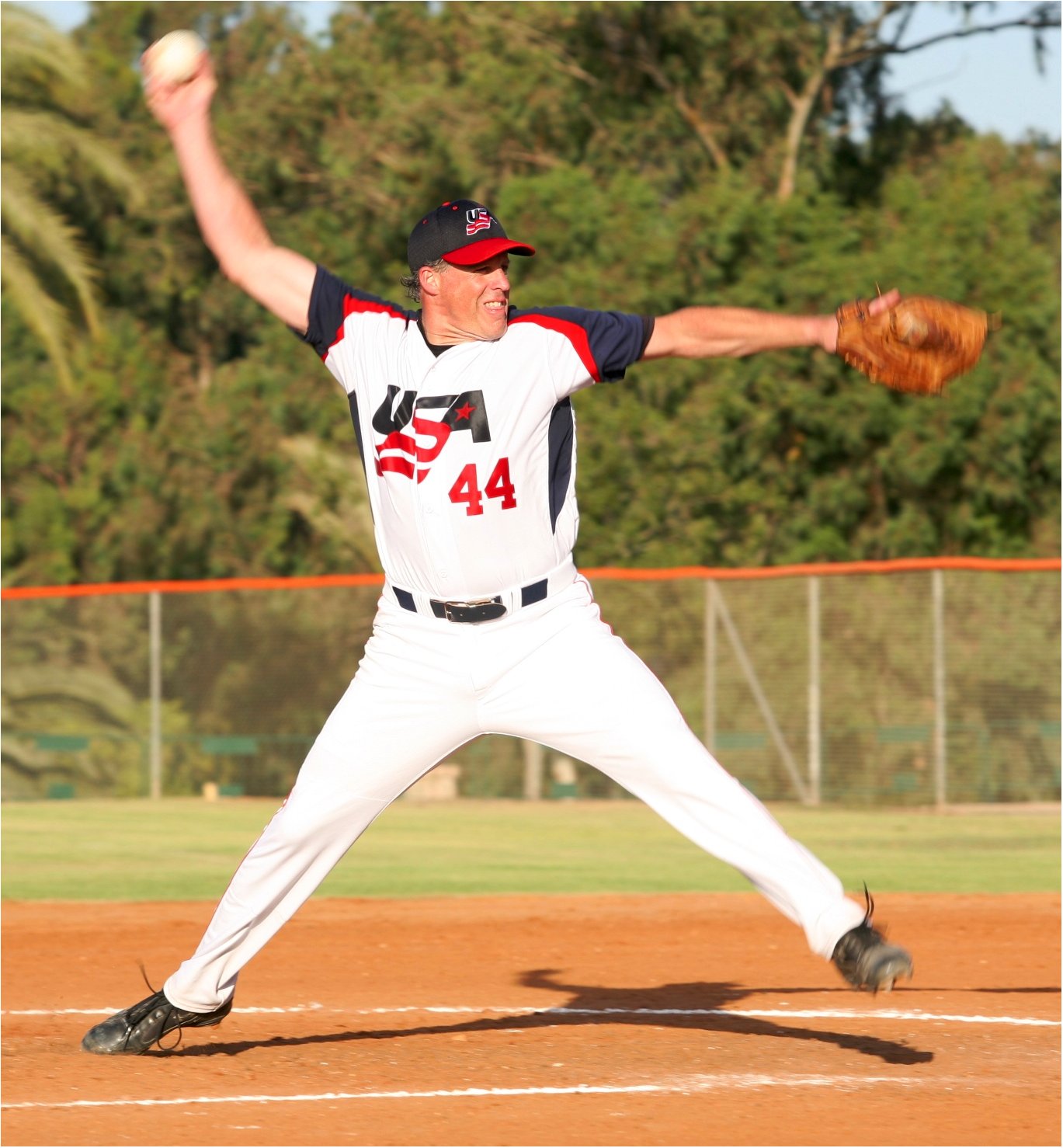

The Maccabi USA Fastpitch Softball team is holding a tryout for the Pan American Maccabi Games taking place in Sao Paolo, Brazil in December of 2011 and for the 19th World Maccabiah Games taking place in Israel July of 2013.

When: Saturday, April 23rd from 3:00 – 7:00

Where: New York City’s Central Park (North Meadow – Field # 2).
Enter park on 5th Avenue / 98th Street or from 96th Street & Central Park West.

Who is eligible: Jewish players 18 & over

What to wear: Baseball pants / metal or molded spikes

In order to attend this tryout, you must send in an official application to Maccabi USA. The form is attached here and available at www.maccabiusa.com.

If you or someone you know is interested in attending, please confirm with Larry Silfen (lsilfen@tsgreporting.com).

