2015 K-Club Invitational
**Host Hotels**

(These rooms are all at a discounted rate; simply inform them that you are with our tournament)

^^^ Holiday Inn Express - $137.56/night (509) 766-2000 ^^^

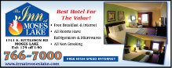
^^^ The Inn at Moses Lake - $117/night (509) 766-7000 ^^^

^^^ Ramada - $129.99/night (509) 766-1000 ^^^

