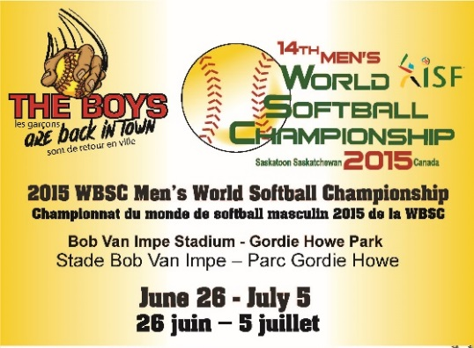
2015 WBSC MEN’S WORLD SOFTBALL CHAMPIONSHIP - MEDIA RELEASE
The Boys are Back in Town- The City of Saskatoon in conjunction with the Saskatoon Amateur Softball Association is pleased to announce, we will be hosting the 2015 WBSC Men’s World Softball Championship, June 25- July 5. A predominant theme that we will be using for this event is “the boys are back in town”, as we are excited about the return of best men’s softball players on the planet to our city. Saskatoon has long been a hotbed for men’s softball and will be the only city in the world to host this event three times, following highly successful events in 1988 and 2009. In the 2009 over 50,000 fans came into the two host ball parks, Bob Van Impe Stadium and Gordie Howe Fastball Field. They joined more than 400 volunteers to make this the most successful Men’s World Softball Championship ever. The success enjoyed in 2009 created a $200,000 Legacy Fund that funded infrastructure projects to enhance the game of Softball and provide opportunities for growth within the youth and adult participant categories for many years. There is little doubt that when the boys cone back this year, they will create more excitement than ever. See our video at https://www.youtube.com/watch?v=2m0VDKbjZd4
Event Details:
New name - The event is no longer referred to the ISF Men’s World Softball Championship. It is now to be referred to as the 2015 WBSC World Men’s Softball Championship. The name change came as a result of the inaugural congress of the World Baseball Softball Confederation in March where the WBSC was formed by the International Baseball Federation (IBAF) and the International Softball Federation (ISF) and is the governing body for baseball and softball.
Sport Canada Hosting Grant – We are honoured to receive a Sport Canada Hosting Grant. “Supporting the hosting of high-calibre international sport events, like the 2015 WBSC Men’s World Softball Championship, is important to the Government of Canada. In fact, during this Year of Sport in Canada, more than 60 international sport events are taking place from coast to coast to coast, including this one in Saskatoon. We are proud to support this event with $150,000 in funding from Sport Canada’s Hosting Program. I congratulate Softball Canada and all the organizers for their great work, and share our Government’s best wishes for a successful tournament. I encourage everyone to cheer on our Canadian team, as many of its athletes will also be competing at the 2015 Pan Am Games!” —The Honourable Lynne Yelich, Minister of State (Foreign Affairs and Consular)
Championship Website and other media: We can be found on the web at http://www.2015isfmensworldsoftball.ca. The website is available in both official languages and has a wide variety of information including: under the events tab you can see the teams and schedule, and you will find event history under the history tab. The website also includes information on the host committee contacts, tickets, volunteers, sponsors and a list of special events to enhance the fan experience. Championship information is also available at https://www.facebook.com/2015ISFmensworlds or on twitter at @ISFMens2015. Video streaming will be available on fee per use basis at Sportscanada.tv
Background Information:
Men’s Softball world championships occur every two years, following a rule change at the 2009 ISF Congress.
- 16 teams will participate from four regions in the 14th WBSC Men’s Softball World Championship, a reach that spans across Asia, Europe, North- and South America, and Oceania.
- There are no age restrictions for this championship.
- Each team roster is allowed a maximum of 17 players.
- Every player is required to hold a passport for the country they represent.
- This is the final softball world championship using the qualification system. All future softball world championships will be ‘open’ format.

The Teams
The first Men’s World Softball Championship took place in Mexico City in 1966. The next 11 championships were dominated by a very group of 3 countries. In 2009 Australia broke in with their first win and in the 2013 championship in Argentina, Venezuela became the first team from South America to win a medal. This year at least half the field will come to the championship with realistic aspirations of winning a medal
Every country will be looking to prove something to the world.
The mighty Black Sox of New Zealand will be returning as defending champions and are looking to claim their sixth world title. A lot has changed since the last worlds as Head coach Mark Sorenson has named seven world championship rookies in his 17-man squad, including 16 year old short stop Coles Evans, the youngest ever to make the Black Sox at this level.
The Aussies and Adam Folkard won their only title in Saskatoon will be looking to get back there to get another, after finishing 3rd two years ago. The Aussie Steelers boast world class experience with six players returning from Saskatoon. They will provide leadership and experience to a team that boasts speed, power, versatility and plenty of youthful energy with 8 championship rookies.
Venezuela winner of the Pan American Softball Championships and 5th in 09, they will be looking to prove to the world that their 2013 silver medal was no fluke.
Argentina coming off a silver medal at the Pan American Softball championship and a 4th place in the 2013 worlds are determined to show local softball fans they are so much better than their 7th place finish the last time they were in Saskatoon.
The traditional powerhouse, United States are four time gold medallists, but will be looking to get back on the podium for the first times since 2000.
The Japanese who have won more medals than any country in the Junior Men s World championships will be fighting to stay up with the elite teams as they were not satisfied with their 6th place finish in the last 2 championships.
The teams from Czech Republic, Denmark. Great Britain and Netherlands will represent Europe and plan to make a mark for European men’s softball on the international scene.
Mexico who has won 2 world championship medals return along with a pair of Latin American countries. Guatemala will be making their world championship debut, and Dominican Republic hope to take advantage of their strong baseball tradition in order to take a step forward in the softball world.
Joining Japan from the WBSC’s Asian region are the teams from Indonesia and the Philippines who will be hoping step up into the top half of the teams in the world.
Canada – Head Coach John Stuart will announce Canada’s World Championship roster on June 3, at 1:30 in a press conference in the Courtyard Room in the Saskatoon Inn. A men’s softball powerhouse since the first time they entered this event, Canada has won the second most medals at the World Championships, second only to New Zealand. They made their way to the podium the last two times the worlds came to Saskatoon but have never been in the final on home soil. In the last world championship they finished first in their pool but lost two straight to Venezuela and Argentina to finish 5^{th.}

