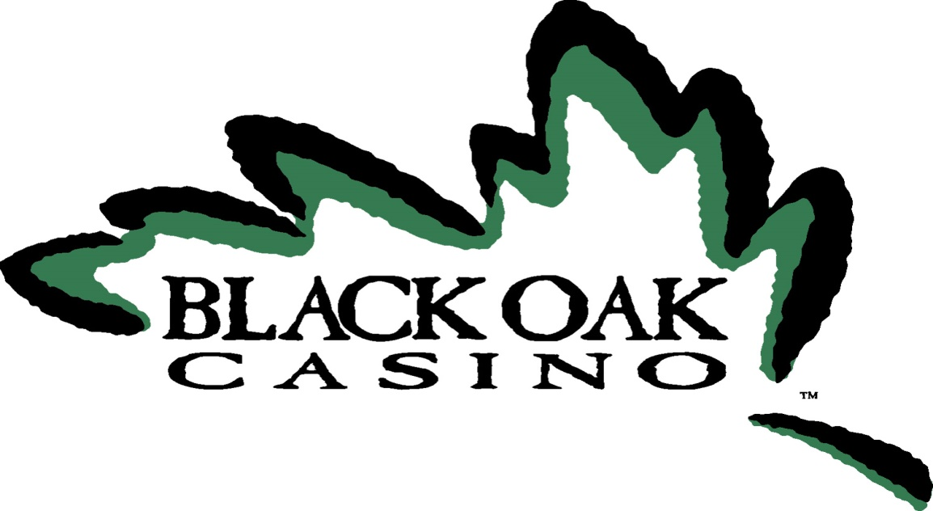
Bob’s 50th year Tournament
Sonora
There will be two divisions
July 9-10, 2016
Standard Park
$ 425 entry fee
Host Hotel: Sonora Aladdin
209 533 4971, rate $89
Call the hotel to reserve your room by June 15th

